4.1 EXAM QUESTIONS MS

1. (a) Increased surface area (1)
more collisions (1) 2

(b) (i) Experiment 2 = 9⋅6 × 10–4 (1)
Experiment 3 = 0⋅010 (1)
Experiment 4 = 8⋅1 × 10–4 (1)
Experiment 5 = 0⋅035 (1)
(ii) k =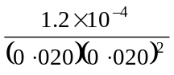 (1) = 15 (1) mol–2 dm6 s–1 (1) 7
[9]

2. (a) order wrt A = 1; 1
order wrt NaOH = 1; 1
Initial rate in Exp 4 = 2.4 × 10–3; 1

(b) (i) r(ate) = k[A]
OR
r(ate) = k[A][NaOH]0; 1
(penalise missing [ ] but mark on)
(penalise missing [ ] once per paper)
(if wrong order, allow only units mark conseq on their rate eqs)
(penalise ka or kw etc)

(ii) 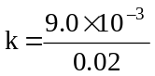; 1
= 0.45; 1
s–1; l
(iii) (large) excess of OH– or [OH–] is large/high; 1
[OH–] is (effectively) constant
OR
[A] is the limiting factor (Q of L mark) 1

[9]
3. (a) Power (or index or shown as x in [ ]x) of concentration term
(in rate equation) (1) 1

(b) 2 (1) 1

(c) (i) Order with respect to A: 2 (1)
Order with respect to B: 0 (1)
(ii) Rate equation: (rate =) k [A]2 (1)
Allow conseq on c(i)
Units for rate constant: mol–1 dm3 s–1 (1) 4
conseq on rate equation
[6]

4. (a) Order with respect to A 1 (1)
Order with respect to B 1 (1)
Order with respect to C 2 (1) 3

(b) Value of k K = 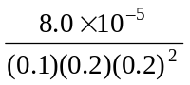 = 0.1
(1) (1)
Units of k mol–3 dm9 s–1 (1)
Initial rate 1.0 × 10–5 (mol dm–3 s–1)
(1) 4
(c) increases (1) 1
[8]

5. (a)
Substances added to an excess of zinc  and 100 cm3 of 0.2 M hydrochloric acid | Volume of  hydrogen/cm3 | Effect on initial rate of  reaction
100cm3 water | 240 (1) | decreased (1)
l0g zinc | 240 (1) | no change (1)
50 cm3 0.2 M hydrochloric acid | 360 (1) | no change (1)
6
(b) Order with respect to A 1 (1)
Order with respect to B 1 (1)
Initial rate 2.8 × 10–5 (mol dm–3 s–1) (1)
either via k = 1.56 × 10–3 (1)
or via table eg expts 2 → 4: rate × × = × (1) 4

(c) (i) Calculation k= 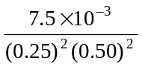(1) = 0.48 (1)
Units 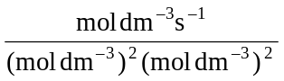 = mol–3 dm9 s–1 (1)

(ii) 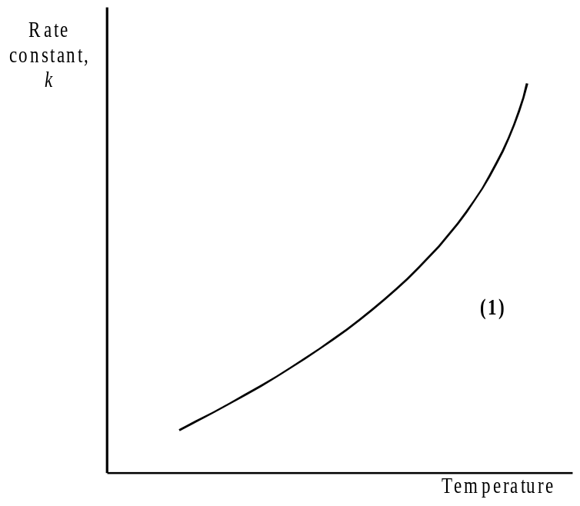 4
[14]

6. (a) exp2 4.0 × 10–3 1
exp3 0.45 × 10–5 1
exp4 9.0 × 10–3 1

(b) 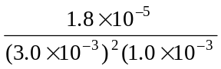 1
2000 1
mol–2 dm6 s–1 1
[6]
7. (a) (i) 2 (1)
(ii) 0 (1) 2

(b) (i) Value of k: k = 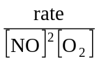 = 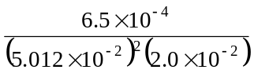 = 13
Units of k: mol–2 dm6 s–1 (1)
(ii) rate = 13 (6.5 × 10–2)2 (3.4 × 10–2)
= 1.9 × 10–3 (mol dm–3 s–1) (1) 4
If k wrong, the mark in (ii) may be gained conseq for their k × 1.437 × 10–4
[6]
8. (a) (i) Experiment 2: 0.4(0) × 10–3 (1)
Experiment 3: 0.15 (1)
Experiment 4: 0.28 (1)
(ii) k = 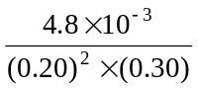 = 0.4(0) mol–2 dm6 s–1
(1) (1) (1) 6

(b) (change in) temperature (1) 1
[7]

9. (a) (i) (Experiment 1 → 2) [A] doubled, ([B] constant,)
rate doubled (1)
stated or shown numerically
(ii) 2 (1)
or shown as ... [B]2 2
(b) (i) k = 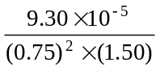 = 1.1(0) × 10–4
(1) (1)
units of k: mol–2 dm6 s–1 (1)
(ii) rate = (1.10 × 10–4) × (0.20)2 × (0.10)
= 4.4(1) × 10–7 (mol dm–3 s–1)
(1) for the answer
Ignore units
Conseq on (i)
Upside down expression for k scores zero in (i) for 9073
but rate = 9073 × (0.2)2 × (0.1) = 36(.3)
conseq scores (1) in (ii)
4
[6]

10. (a) (i)
Expt | Initial  [A]/mol dm–3 | Initial  [B]/mol dm–3 | Initial  rate/mol dm–3s–1
1 | 0.30 | 0.30 | 1.5 × 10–2
2 | 0.60 (1) (0.58 to 0.63) | 0.60 | 6.0 × 10–2
3 | 0.45 | 1.20 (1) (1.17 to 1.25) | 9.0 × 10–2
4 | 0.90 | 0.60 | 9.0 × 10–2 (1)  (8.6 to 9.2 ×10–2)

(ii) 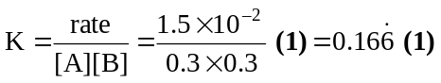 (or 0.17 or 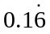)
(1) (1)
units: mol–1 dm3 s–1 (1) 6

(b) surface area more (than doubled) (1)
many more collisions (1) 2
[8]

11. (a) 2 (1)
0 (1)
rate = k[J]2 (1) 3

(b) k = 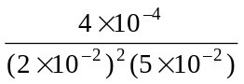 (1) = 20 (1) 3
mol–2 dm6 s–1

(c) rate = k [ ]n ∴[ ]n = 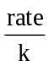
units: 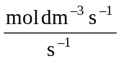 = mol dm–3 ∴n = 1 (2)
greater/increase (1) 3
[9]

